Hybrid Enterprise Infrastructure Lab
(On-Premises Microsoft 365)

Chhiring Moktan
Cmokta03/Hybrid-Enterprise-Infrastructure-Lab-On-Premises-Microsoft-365-
Start date:03/17/2026
Completed date:03/26/2026

Phase 1 – Core Infrastructure & Connectivity
  - Hostname and Network Baseline
Objective: To establish a professional corporate identity and ensure a reliable network baseline for the Domain Controller.
Steps Performed: Navigated to Local Server settings to change the computer name to DC01. Configured the IPv4 properties with a Static IP address, Subnet Mask, and Preferred DNS to ensure the server maintains a constant network location.
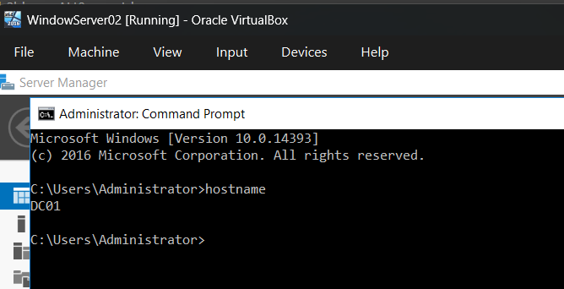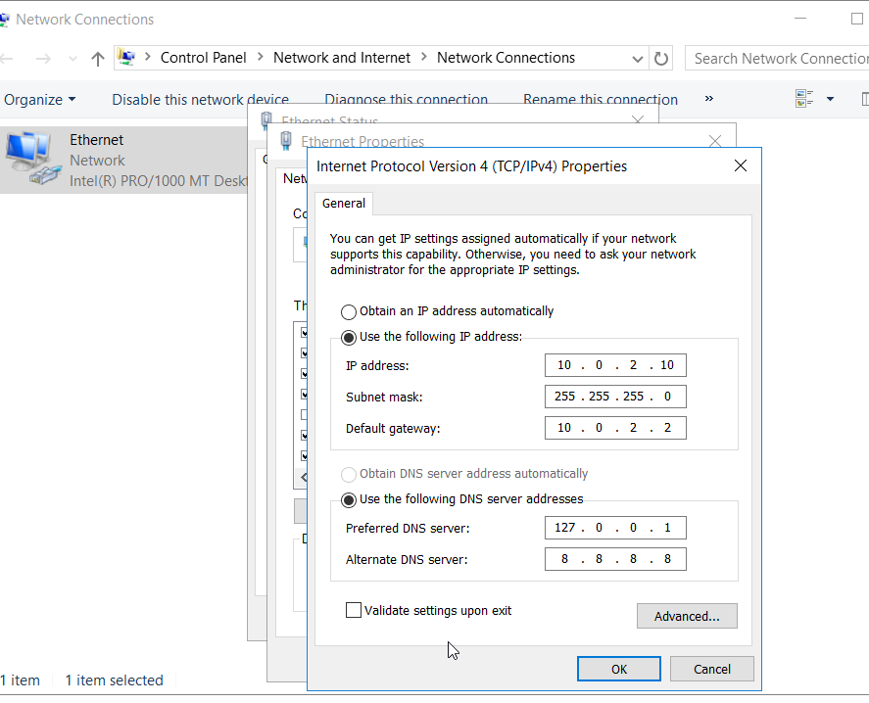
Explanation: These images show the transition from a default workgroup machine to a prepared server node. Static addressing is a prerequisite for all Active Directory roles and DNS stability. Result / Validation: Server identity is modernized and network communication is locked to a permanent address.

  - Domain Identity & AD DS Installation
Objective: To initialize the Directory Services and prepare the environment for custom domain logins.
Steps Performed: Added the Alternate UPN Suffix in AD Domains and Trusts. Installed the Active Directory Domain Services (AD DS) role via Server Manager and promoted the server to a Domain Controller for the forest.
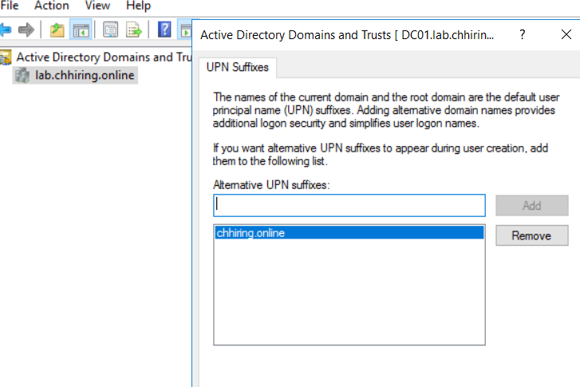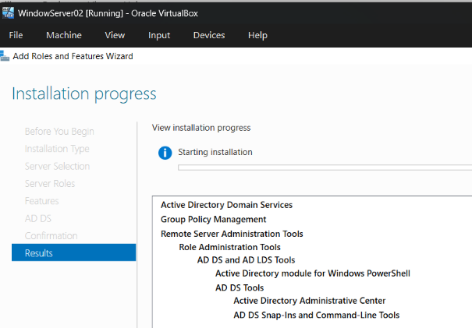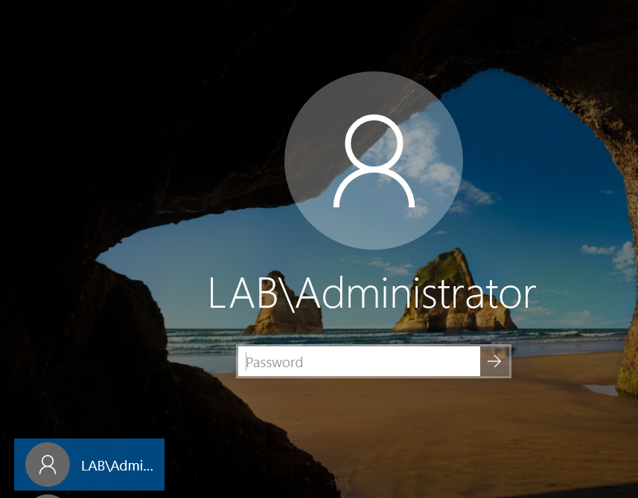

Explanation: Promoting the server transforms it into the "Central Brain" of the network, allowing for centralized management of all users, computers, and security policies. Result / Validation: The server is now a functional Domain Controller (DC) capable of authenticating domain accounts.

  - Laboratory Network & Connectivity Verification
Objective: To bridge the virtual gap between the Server and the Client VM and verify the "Soni" user context.
Steps Performed: Configured the VirtualBox Internal Network settings to allow private communication. Joined the Windows 10 VM to the domain and executed the whoami command to verify the active user context.
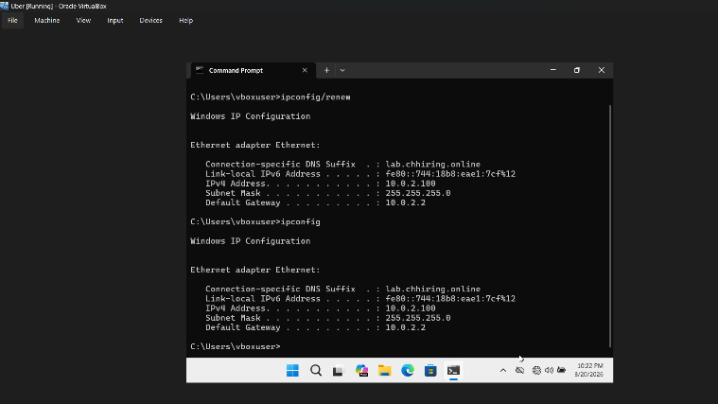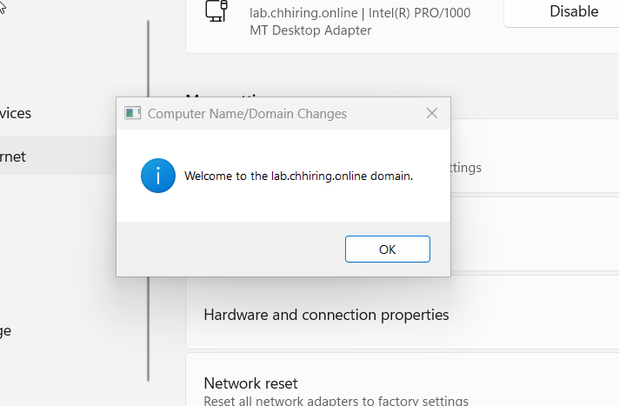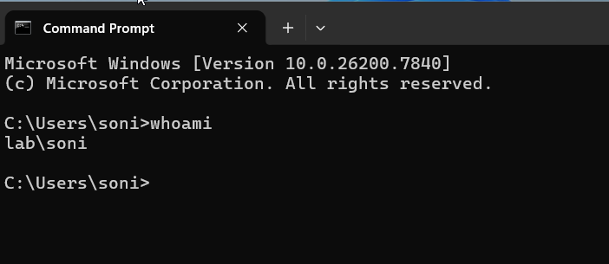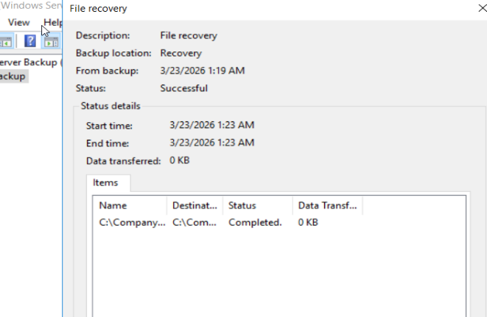Explanation: This phase confirms that the virtual "cabling" is correct and that the Client VM is successfully receiving identity information from the Domain Controller. Result / Validation: "Welcome to the domain" message confirmed; whoami command returns LAB\Soni, proving successful domain authentication.

Phase 2 – Active Directory & Network Management
2.1 Organizational Hierarchy & User Provisioning
Objective: To mirror a real-world corporate structure for targeted policy application.
Steps Performed: Created a primary Organizational Unit (OU) and nested sub-OUs for specific departments. Created the standard user account for "Soni" within the newly designed structure.
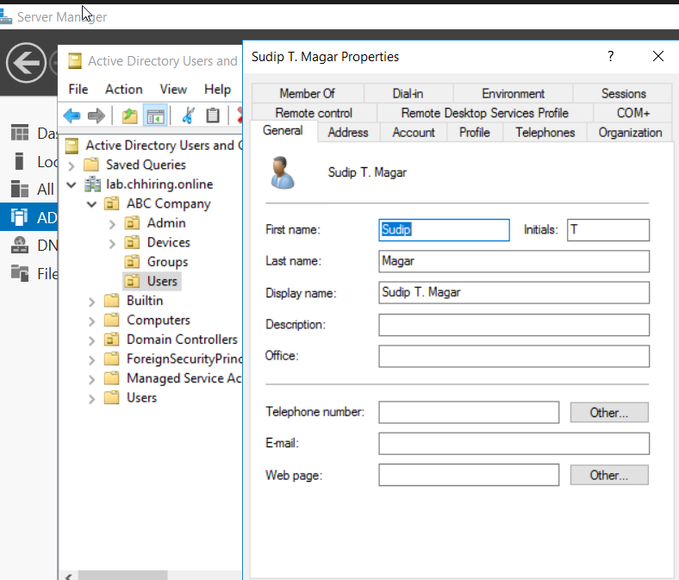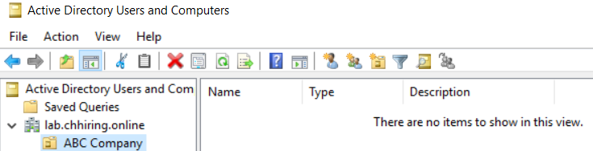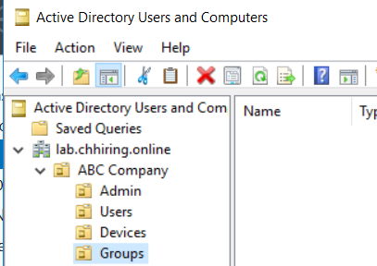
Explanation: Proper OU design is the foundation of Group Policy; it ensures that administrative rules are applied only to the intended departmental containers.
Result / Validation: Users and departmental containers are logically organized and visible within the AD Users and Computers console.

2.2 Core Network Services (DHCP & DNS)
Objective: To automate client addressing and provide the lab environment with external name resolution.
Steps Performed: Installed and authorized the DHCP Role to manage IP distribution for client VM. Configured DNS Forwarders and verified that Reverse Lookup Zones were functional.
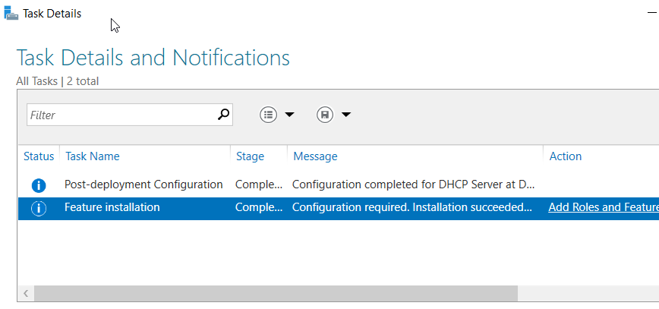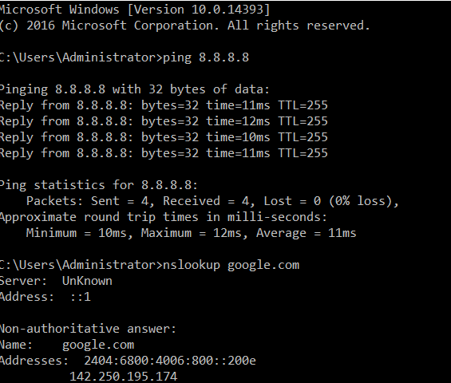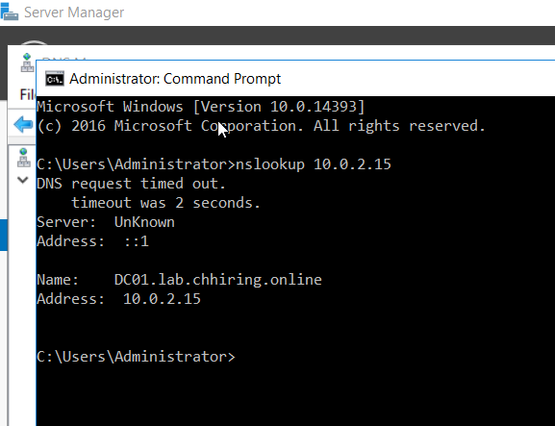
Explanation: DHCP removes the need for manual IP entry on clients, while DNS Forwarders allow the internal lab to resolve external internet addresses for updates and browsing.
Result / Validation: The Client VM receives an IP address automatically; DNS Reverse Lookup confirms the server can resolve names to IPs.

Phase 3 – Group Policy & Resource Control
3.1 Security Hardening & Desktop Restrictions
Objective: To protect the server and restrict the user’s desktop environment on the workstation.
Steps Performed: Configured the Default Domain Password Policy for complexity. Created a Group Policy Object (GPO) to block access to the Control Panel and verified the restriction on client VM.
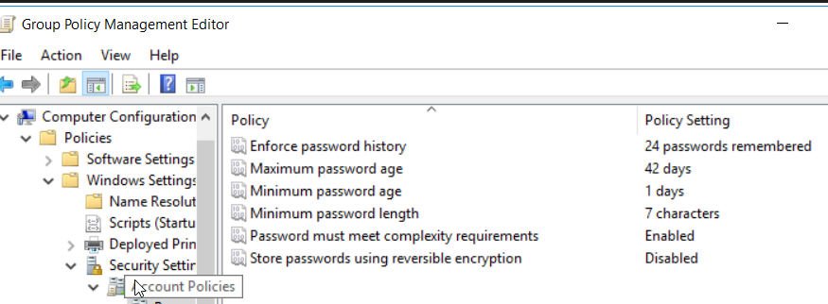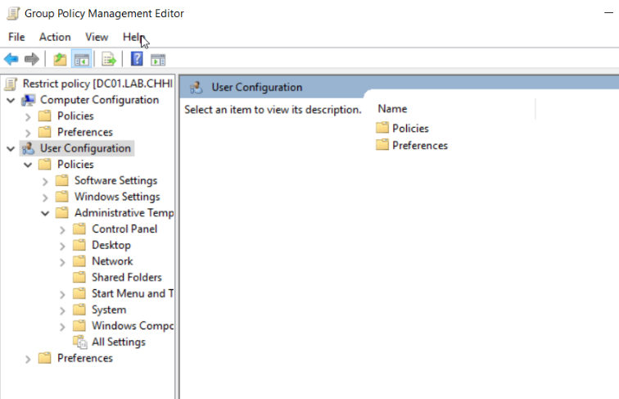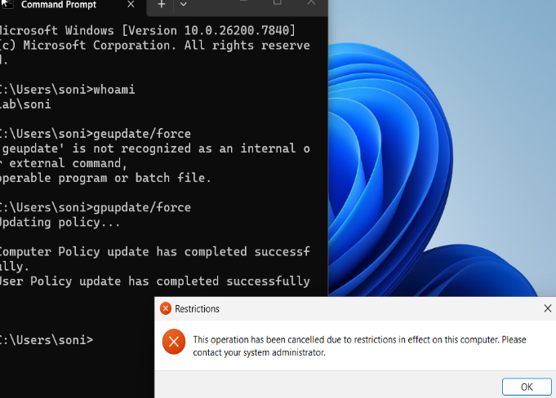
Explanation: These policies prevent "Shadow IT" or accidental system changes by standard users, ensuring the workstation remains in a well-good state.
Result / Validation: Password rules are enforced; Soni receives a "Restrictions" warning when attempting to open prohibited system settings.

3.2 File Services & Storage Governance
Objective: To provide secure, mapped storage with strict data limits and access controls.
Steps Performed: Created a CompanyData network share with specific NTFS permissions. Configured a GPO for automated Drive Mapping (Z: Drive) and implemented FSRM Quotas to limit folder size.
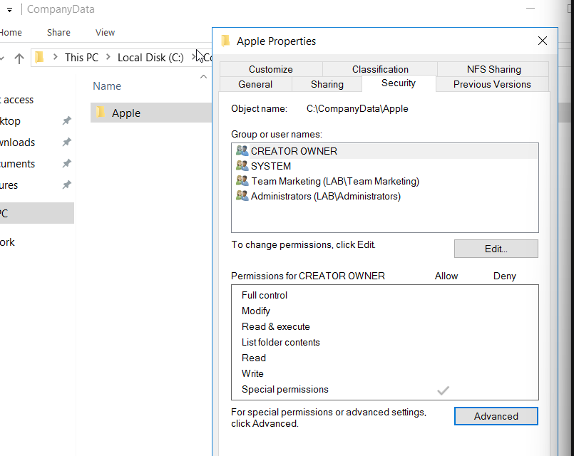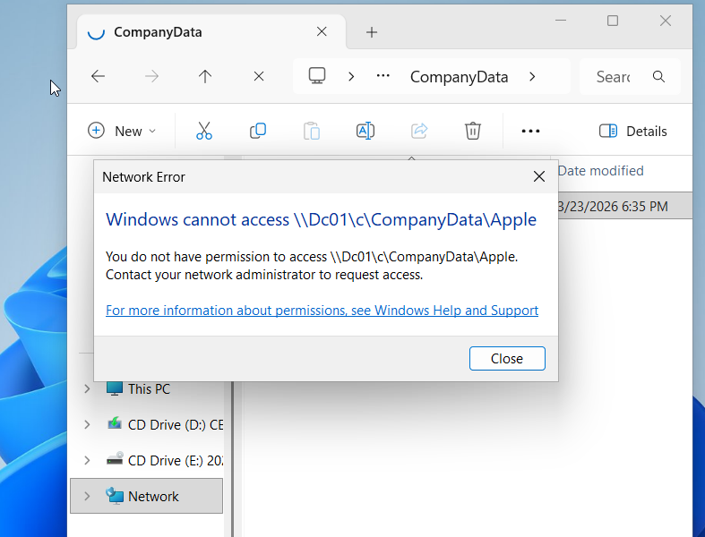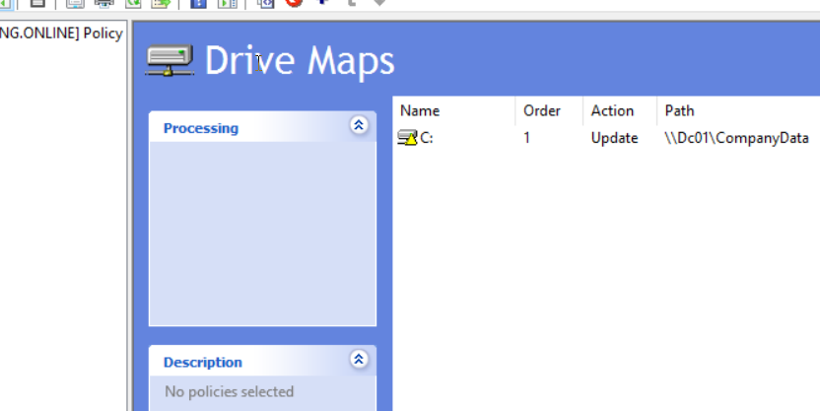
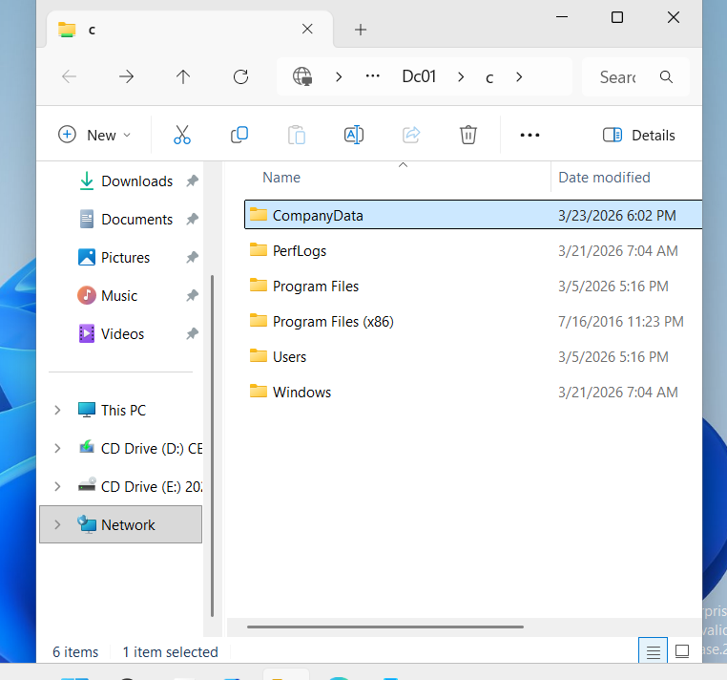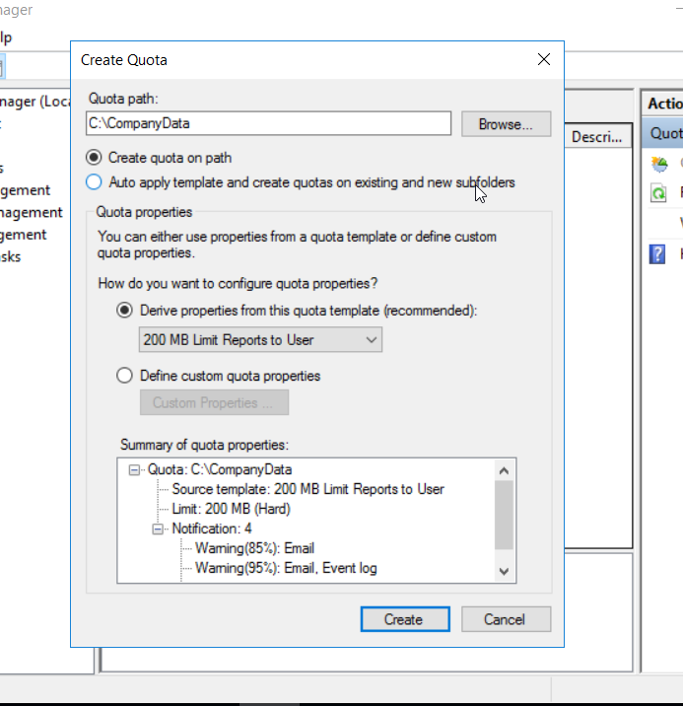
Explanation: This ensures users have a centralized place to save work automatically while preventing any single user from exhausting the server's storage capacity.
Result / Validation: Soni sees the Z: drive upon login; "Access Denied" appears when she tries to enter folders belonging to other departments.

Phase 4 – Monitoring & Disaster Recovery
4.1 System Health & Security Auditing
Objective: To maintain visibility in server performance and security-sensitive events.
Steps Performed: Enabled Advanced Security Auditing for logon events. Configured Performance Monitor to track CPU/RAM usage and hardened the perimeter using Windows Firewall rules.
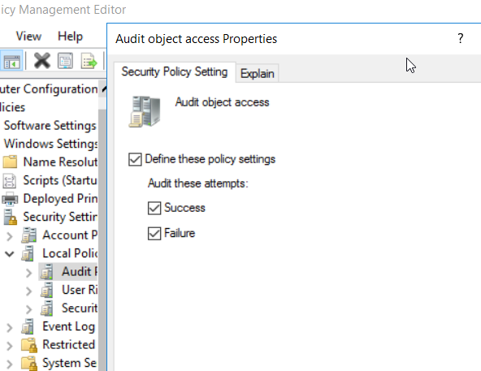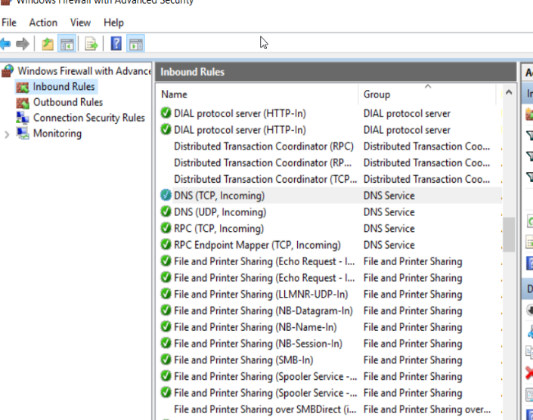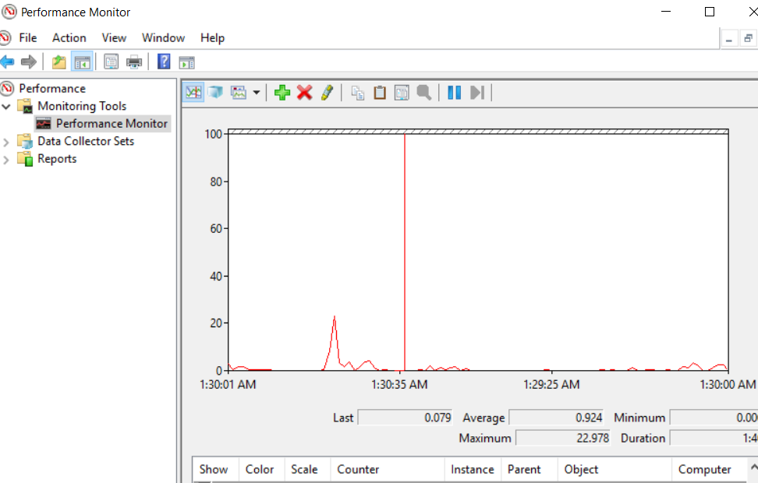
Explanation: Auditing provides the forensic trail needed for compliance, while Performance Monitoring acts as an early warning system for hardware resource bottlenecks.
Result / Validation: Real-time health data is captured; security logs in Event Viewer show successful and failed domain login attempts.

4.2 Disaster Recovery & Data Restoration
Objective: To ensure business continuity through verified backups and restoration procedures.
Steps Performed: Installed the Windows Server Backup feature and performed a full system backup. Executed a recovery test by deleting a file and restoring it from the backup catalog.
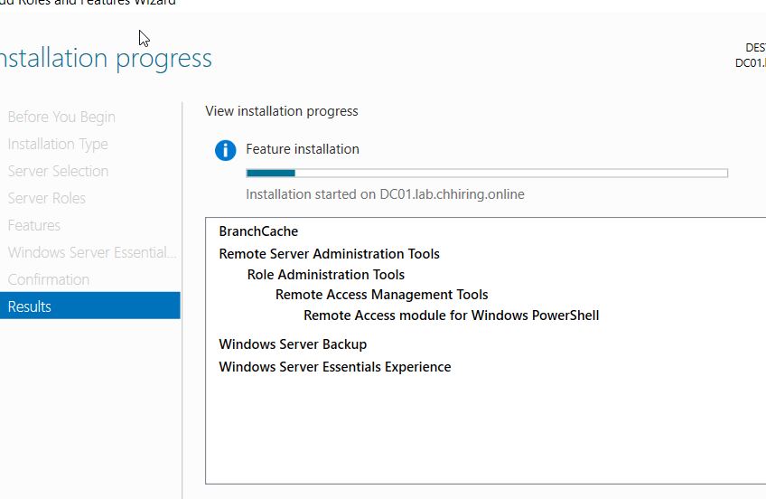
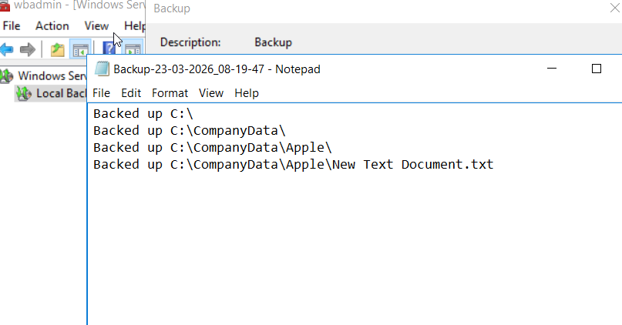
Explanation: A backup strategy is only valid if the data can be recovered. This test proves the organization is protected against accidental deletion or system failure.
Result / Validation: Backup status shows "Successful"; the deleted file is restored to its original location with all permissions intact.

Phase 5 – Remote Access & Hybrid Cloud Integration
5.1 Remote Desktop Configuration and Verification
Objective: To enable and verify secure remote management for the Domain Controller.
Steps Performed: Navigated to System Properties to enable "Allow remote connections to this computer." Configured the firewall to permit RDP traffic and successfully established a remote session from the management workstation to the DC.
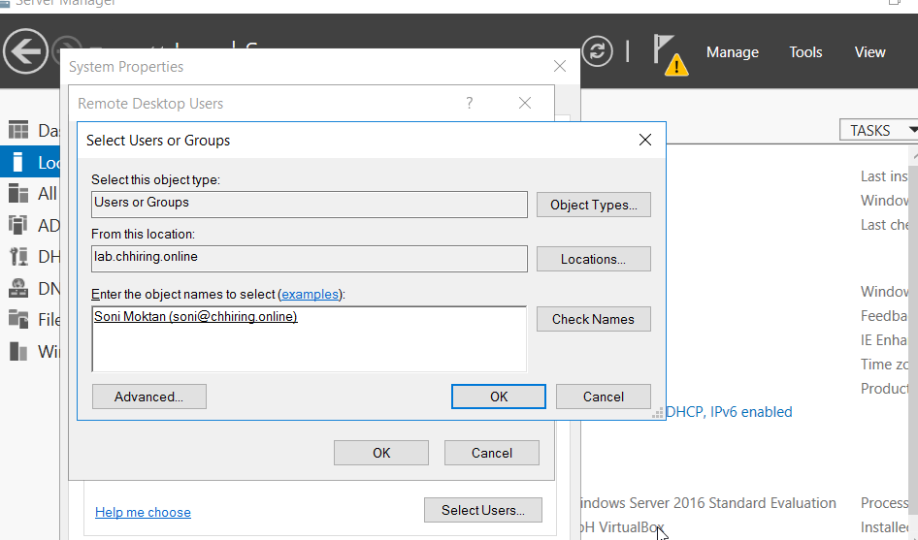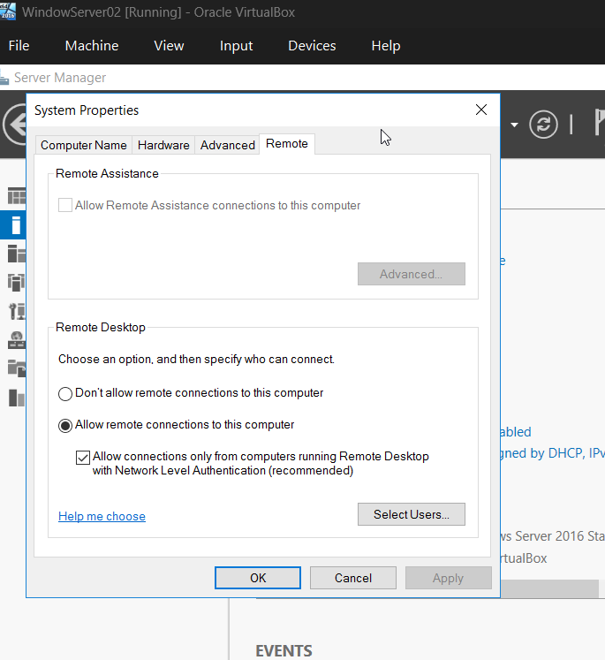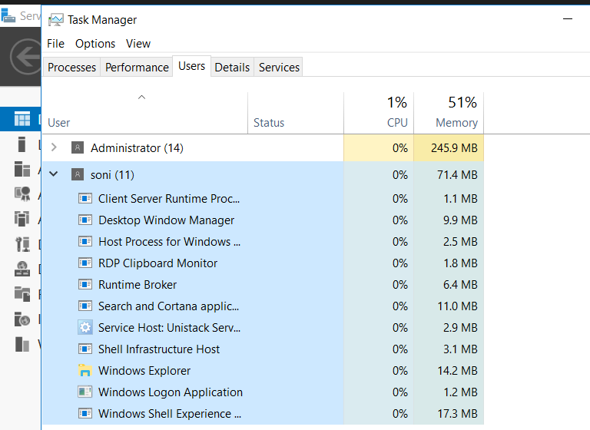
Explanation: Enabling RDP allows the server to be managed remotely, which is essential for headless data center operations. These steps confirm that both the system settings and network permissions are correctly aligned to allow administrative access.
Result / Validation: The Remote Desktop status is "Enabled" and the server is successfully accessed via a remote window with full functionality.
5.2 Microsoft Entra Cloud Synchronization
Objective: To synchronize local Active Directory identities to the Microsoft 365 cloud environment.
Steps Performed: Installed and configured the Microsoft Entra Provisioning Agent. Set up the synchronization service to map local user objects from the LAB domain to the Entra ID tenant to enable hybrid identity.
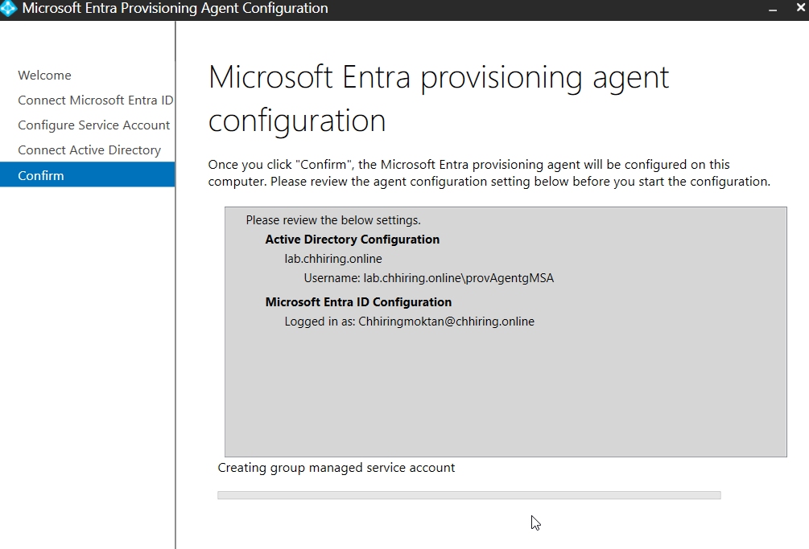
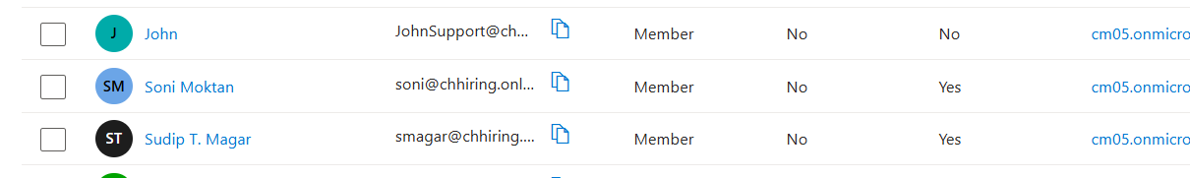
Explanation: This process creates a bridge between the on-premises DC and the cloud. It ensures that users created locally are automatically provisioned in the cloud, allowing for a single set of credentials across the entire organization.
Result / Validation: The synchronization agent is "Healthy" and the local AD objects are successfully exported to the Microsoft Entra portal.

